**Target Journals:**

**Title**:

**Running Head:**

**Author List:** Evan A. Perkowski, Nicholas G. Smith

**Author Affiliations:** Department of Biological Sciences, Texas Tech University, Lubbock, TX

**Manuscript compilation details**

**Abstract:** XX words

**Main text word count**: XX words

Introduction: XX words

Methods: XX words

Results: XX words (not including text in figures or tables)

Discussion: XX words (XX% of total word count)

**References**: XX

**Tables and Figures**: XX

**Supplemental Information**:

**Abstract**

Plants acclimate to increasing CO2 by reducing leaf nutrient allocation and photosynthetic capacity at the leaf level, a response that often occurs alongside growth stimulation at the whole plant level. Nutrient limitation has been hypothesized to be the primary driver of plant acclimation to CO2, as nutrient availability commonly limits primary productivity and may decrease with increasing CO2 over time. However, recent work leveraging photosynthetic least-cost theory indicates that these acclimation responses may instead be the result of optimal resource investment toward photosynthetic capacity, which maximizes nutrient allocation to whole plant growth. To understand whether nutrient limitation or optimal leaf resource investment controls plant acclimation to CO2 and how nutrient acquisition strategy modifies these responses, we grew soybean under two atmospheric CO2 levels, two inoculation treatments, and nine soil nitrogen fertilization treatments in a full factorial growth chamber experiment.

We found that …

These results suggest that XX is the dominant control of plant acclimation responses to CO2, providing important empirical data needed to refine our understanding of mechanisms driving plant acclimation to CO2.

**Keywords**

photosynthetic acclimation, soil nutrient availability, nutrient acquisition, global change

**Introduction**

Photosynthesis in terrestrial systems is constrained by ecosystem carbon and nutrient biogeochemical cycle dynamics (Hungate et al., 2003). Specifically, plants fix carbon dioxide from the atmosphere into simple sugars using enzymes, such as Ribulose-1,5-bisphosphate carboxylase/oxygenase (“Rubisco”), that have large nitrogen requirements to build and maintain (Evans, 1989). Recent photosynthetically derived carbon (“photosynthate”) can be accumulated as biomass (cite), lost as a substrate of plant respiration (Glover, 1973), or allocated belowground to acquire nutrients (cite). Belowground photosynthate can be used by plants to acquire nutrients either directly from the soil (cite), indirectly through root exudates that prime soil microbial communities and organic matter decomposition (Bengtson et al., 2012), or indirectly through symbioses with mycorrhizal fungi and/or symbiotic nitrogen-fixing bacteria (S. E. Smith & Read, 2008).

Anthropogenic activities have been the proximal cause of increasing atmospheric CO2 concentrations since the start of the Industrial Revolution in the mid 1700s. The Intergovernmental Panel on Climate Change suggests that atmospheric CO2 concentrations will continue to increase under business-as-normal emissions scenarios, with some scenarios suggesting that CO2 concentrations will exceed 1,000 ppm by 2100 (IPCC, 2013). Plant ecologists and physiologists have been long interested in understanding long-term effects of elevated CO2 on plant photosynthetic processes, where large swaths of studies report that increasing CO2 concentrations generally results in reductions in leaf nutrient allocation and photosynthetic capacity, a pattern that often corresponds with a stimulation in whole plant growth and net primary productivity (Ainsworth et al., 2002; Ainsworth & Rogers, 2007; Curtis, 1996; Makino, 2003; Morgan et al., 2004; Poorter et al., 2022; N. G. Smith & Dukes, 2013).

There are two conflicting hypotheses that explain the inverse leaf and whole plant acclimation responses to increasing CO2. Some have hypothesized that nutrient limitation may be the primary control of plant acclimation to CO2, as nutrient availability commonly limits primary productivity and may decrease over time in elevated CO2 environments (Fay et al., 2015; LeBauer & Treseder, 2008; Liang et al., 2016; Luo et al., 2004) through chronic stimulations in whole plant nutrient demand. The nutrient limitation hypothesis predicts that plants decrease leaf nutrient allocation and photosynthetic capacity as a direct response to progressive reductions in soil nutrient availability due to elevated CO2. The nutrient limitation hypothesis also predicts an acute stimulation in whole plant growth due to elevated CO2 that dampens over time because of progressive nutrient limitation.

An alternative hypothesis to the leaf response, based on photosynthetic least-cost theory (Prentice et al., 2014; Wright et al., 2003) suggests that plants growing under elevated CO2 environments instead downregulate nutrient allocation to Rubisco to optimize resource use efficiencies at the leaf level, which maximizes resource allocation to whole plant growth. Importantly, the nutrient limitation and least-cost hypotheses predict similar leaf acclimation responses to CO2, but result in different outcomes at the whole plant level.

Nutrient acquisition strategy, or the method in which plants acquire nutrients, may also impact how plants acclimate to CO2 (N. G. Smith & Keenan, 2020; Terrer et al., 2018). Plants acquire nutrients via direct uptake from their rooting systems or through symbiotic associations with mycorrhizal fungi or symbiotic nitrogen-fixing bacteria (S. E. Smith & Read, 2008). In plants that form associations with microbial symbionts, plants allocate recent photosynthate belowground in exchange for nutrients acquired by microbial symbionts. However, not all microbial symbioses require the same belowground carbon investments to exchange nutrients. Carbon costs to acquire nitrogen, or the amount of carbon plants allocate belowground per nitrogen acquired, vary across nutrient acquisition strategies and soil nutrient availability thresholds (Perkowski et al., 2021). Interestingly, a recent global meta-analysis indicates that carbon costs to acquire nitrogen may modify plant acclimation responses to CO2 (Terrer et al., 2016, 2018), although manipulation experiments that directly test the mechanisms driving these responses are rare.

In this study, I will investigate the influence of inoculation with symbiotic nitrogen-fixing bacteria and direct soil nutrient manipulation on soybean (*Glycine max* L.) acclimation responses to CO2. This experiment will determine whether nutrient limitation or optimal leaf resource investment is the primary driver of plant acclimation to CO2 and how nutrient acquisition strategy modifies these responses. I hypothesize that leaf acclimation to CO2 will be driven by optimal leaf resource investment, not nutrient limitation. Specifically, I predict that increasing CO2 will decrease stomatal conductance, leaf nutrient allocation, and photosynthesis independent of nutrient acquisition strategy or soil nutrient availability, which will maximize resource allocation to whole plant growth. While I do not expect that soil nutrients or acquisition strategy will modify leaf acclimation responses to CO2, I do expect that soil nutrient availability will increase the positive effect of CO2 on whole plant growth. I also predict that inoculation with nitrogen-fixing bacteria will increase whole plant growth responses to CO2. However, I only expect an inoculation effect in low soil nutrient environments, as inoculated individuals should shift away from nitrogen fixation and toward direct uptake with increasing soil nutrient availability (Perkowski et al., 2021; Rastetter et al., 2001).

**Methods**

*Seed treatments and experimental design*

*Glycine max* L. (Merr) seeds were planted in 144 6-liter surface sterilized pots (NS-600, Nursery Supplies, Orange, CA, USA) containing a steam-sterilized 70:30 v:v mix of *Sphagnum* peat moss (Premier Horticulture, Quakertown, PA, USA) to sand (fill in manufacturer info here). Before planting, all *G. max* seeds were surface sterilized in 2% sodium hypochlorite for 3 minutes, followed by three separate 3-minute washes with ultrapure water (MilliQ 7000; MilliporeSigma, Burlington, MA USA). A subset of surface sterilized seeds were then inoculated with *Bradyrhizobium japonicum* (Verdesian N-Dure™ Soybean, Cary, NC, USA) in a slurry following manufacturer recommendations (3.12 g inoculant and 241 g deionized water per 1 kg seed).

Seventy-two pots were randomly planted with seeds inoculated with *B.* *japonicum*, and the remaining 72 pots were planted with uninoculated seeds. Thirty-six pots within each inoculation treatment were randomly placed in one of two atmospheric CO2 treatments (ambient and 1000 μmol mol-1 CO2). Pots within each unique inoculation-by- CO2 treatment combination randomly received one of nine soil nitrogen fertilization treatments equivalent to 0, 35, 70, 105, 140, 210, 280, 350, or 630 ppm N. Nitrogen fertilization treatments were created using a modified Hoagland solution (Hoagland & Arnon, 1950) and were designed to keep concentrations of other macronutrients and micronutrients equivalent across treatments (Table S1). Fertilization treatments were applied twice per week in 150mL doses as topical agents to the soil surface throughout the duration of the experiment.

*Growth chamber conditions*

Upon experiment initiation, pots were randomly placed in one of six Percival LED-41L2 growth chambers (Percival Scientific Inc., Perry, IA, USA). The experiment was conducted over two iterations due to chamber space limitation. The two iterations were conducted such that one iteration included all elevated CO2 pots and the second iteration included all ambient CO2 pots. CO2 concentrations for the ambient CO2 treatment averaged 439±5 μmol mol-1 CO2, while the CO2 concentrations for the elevated CO2 treatment averaged 989±4 μmol mol-1 CO2.

Daytime growing conditions were simulated using a 16-hour photoperiod, with incoming light radiation set to chamber maximum (mean±SD: 1240±32 μmol m-2 s-1 across chambers), air temperature set to 25°C, and relative humidity set constant to 50%. The remaining 8 hours simulated nighttime growing conditions, with incoming light radiation set to 0 μmol m-2 s-1, chamber temperature set to 17°C, and relative humidity set to 50%. Transitions between daytime and nighttime growing conditions were simulated by ramping incoming light radiation in 45-minute increments and temperature in 90-minute increments over a 3-hour period (Table S2).

Including the two 3-hour ramping periods, pots grew under average (± SD) daytime light intensity of 1049±27 μmol m-2 s-1. In the elevated CO2 iteration, pots grew under 24.0±0.2°C during the day, 16.4±0.8°C during the night, and 51.6±0.426% relative humidity. In the ambient CO2 iteration, pots grew under 23.9±0.2°C during the day, 16.0±1.4°C during the night, and 50.3±0.2% relative humidity. We attempted to account for any climatic differences across the six chambers by shuffling the same group of pots throughout the growth chambers. This was done by iteratively moving pots on the top rack of a chamber to the bottom rack and pots on the bottom rack of a chamber to the top rack of the adjacent chamber. We moved pots within and across chambers every day throughout the course of each experiment iteration.

*Leaf gas exchange measurements*

Gas exchange measurements were collected on the most recent fully expanded leaf for all experimental pots on the seventh week of development. Specifically, we measured net photosynthesis (*A*net; μmol m-2s-1), stomatal conductance (*g*s; mol m-2s-1), and intercellular CO2 (*C*i; μmol mol-1) concentrations across a range of atmospheric CO2 concentrations (i.e. an *A*net/*C*i curve) using the Dynamic Assimilation Technique™. The Dynamic Assimilation Technique™ has been previously shown in *G. max* to correspond well with traditional steady-state CO2 response curves (Saathoff & Welles, 2021). *A*net/*C*i curves were generated using the split method, which measured *A*net, *g*s, and *C*i along a reference CO2 ramp down from 420 µmol mol-1 CO2 to 20 µmol mol-1 CO2, followed by a ramp up from 420 µmol mol-1 CO2 to 1620 µmol mol-1 CO2 after a 90-second wait period at 420 µmol mol-1 CO2. The ramp rate for each curve was set to 200 μmol mol-1 min-1, logging every five seconds, which generated 96 data points per response curve. All *A*net/*C*i curves were generated with the cuvette flow rate stabilized at 500 mol s-1, fan set to 10,000rpm, vapor pressure deficit set to 1.5 kPa, leaf temperature set to 25°C, and incoming light radiation set to 2000 μmol m-2 s-1.

After *A*net/*C*i curves were generated, we subjected individuals to at least a 30-minute period of darkness. Dark respiration (*R*d; μmol m-2 s-1) measurements were then collected on the same focal leaf used to generate *A*net/*C*i curves. Measurements were collected on a 5-second log interval for 60 seconds after stabilizing in a LI-6800 cuvette where flow rate was stabilized at 500 mol s-1, reference CO2 was set to 420 μmol mol-1, vapor pressure deficit was set to 1.5 kPa, leaf temperature was set to 25°C, and incoming light radiation was set to 0 μmol m-2 s-1. A single dark respiration value was determined for each focal leaf by calculating the absolute assimilation average across the logging interval.

*Leaf trait measurements*

At the end of the seventh week of the experiment, leaf trait measurements were collected on the same focal leaf used to generate *A*net/*C*i response curves. Images of each leaf were curated using a flat-bed scanner to determine wet leaf area using the 'LeafArea' R package (Katabuchi, 2015), which automates leaf area calculations using ImageJ software (Schneider et al., 2012). Each leaf was dried at 65C for at least 48 hours, and subsequently weighed and ground until homogenized. Leaf mass per area (*M*area; g cm-2) was calculated as the ratio of dry leaf biomass to fresh leaf area. Using subsamples of ground and homogenized leaf biomass, we also determined leaf nitrogen content (*N*mass; g g-1) through elemental combustion analysis (Costech-4010, Costech, Inc., Valencia, CA, USA), and sent samples to the University of California-Davis Stable Isotope Facility to determine leaf δ13C and δ15N. Leaf nitrogen content per unit leaf area (*N*area; gN m-2) was calculated by multiplying *N*mass and *M*area.

We used leaf δ13C values to estimate the ratio of intercellular (*C*i) to extracellular (*C*a) CO2 (χ; Pa Pa-1) following the approach of Farquhar *et al.* (1989) described in Cernusak *et al.* (2013). While intercellular and extracellular CO2 concentrations were directly measured during each CO2 response curve, deriving χ from δ13C provides a more integrative estimate of the *C*i:*C*a over an individual leaf’s lifespan . We derived χ as:

(Eqn. 1)

Δ13C represents the relative difference between leaf δ13C (‰) and air δ13C (‰), and is calculated from the following equation:

$Δ^{13}C=\frac{δ^{13}C_{air}-δ^{13}C_{leaf}}{1+δ^{13}C_{leaf}}$ (Eqn. 2)

where δ13Cair is assumed to be -8‰ (Farquhar et al., 1989; Keeling et al., 1979), *a* represents the fractionation between 12C and 13C due to diffusion in air, assumed to be 4.4‰, and *b* represents the fractionation caused by Rubisco carboxylation, assumed to be 27‰ (Farquhar et al., 1989).

*A*/*C*i *curve-fitting and parameter estimation*

We fit *A*net/*C*i curves of each individual using the ‘fitaci’ function in the ‘plantecophys’ R package (Duursma, 2015). This function estimates the maximum rate of Rubisco carboxylation (*V*cmax; µmol m-2 s-1) and maximum rate of electron transport for RuBP regeneration (*J*max; µmol m-2 s-1) based on the Farquhar, von Caemmerer, and Berry biochemical model of C3 photosynthesis (Farquhar et al., 1980). Triose phosphate utilization (TPU) limitation and dark respiration were included in all curve fits. We determined Michaelis-Menten coefficients for Rubisco affinity to CO2 (*K*c; μmol mol-1) and O2 (*K*o; mmol mol-1), and the CO2 compensation point *(Γ*\*; μmol mol-1) using leaf temperature and equations described in Medlyn et al. (2002) and derived in Bernacchi et al. (2001). Specifically, *K*c and *K*o were calculated as:

$K_{c}={404.9*exp}^{\left(\frac{79430(T_{k}-298)}{298RT_{k}}\right)}$ (Eqn. 3a)

and

$K_{o}={278.4*exp}^{\left(\frac{36380(T_{k}-298)}{298RT_{k}}\right)}$ (Eqn. 3b)

while *Γ*\* was calculated as:

$Γ^{*}={42.75*exp}^{\left(\frac{37830(T_{k}-298)}{298RT_{k}}\right)}$ (Eqn. 3c)

In all three equations, *T*k is the leaf temperature (in Kelvin) during each CO2 response curve and R is the universal gas constant (8.314 J mol-1 K-1).

*V*cmax, *J*max, and *R*d were estimated using measurements that were collected at a common leaf temperature (25°C). Therefore, there was no need to temperature standardize rate estimates. For clarity, we reference rate estimates from this point forward as *V*cmax25, *J*max25, and *R*d25.

*Stomatal limitation*

We quantified the extent by which stomatal conductance limited photosynthesis (*l*; unitless) following equations originally described in Farquhar & Sharkey (1982). Stomatal limitation is calculated as:

$l=1-\frac{A_{net}}{A_{mod}}$ (Eqn. 6)

*A*net represents the net photosynthesis rate where reference CO2 was set to 420 μmol mol-1 CO2, while *A*mod represents the photosynthetic rate where *C*i = *C*a. *A*mod was calculated as:

$A_{mod}=V_{cmax}\frac{400-Γ^{*}}{400+Κ_{m}}-R_{d}$ (Eqn. 7)

*V*cmax represents the temperature unstandardized maximum rate of Rubisco carboxylation. We used the temperature unstandardized *V*cmax value because *A*net values were not standardized to 25°C. *R*d represents dark respiration, which was the dark respiration value we temperature standardized to the CO2 response curve fit. Γ* (Pa) is the CO2 compensation point in the absence of dark respiration, while *K*m is the Michaelis-Menten coefficient for Rubisco-limited photosynthesis. *K*m was calculated as:

$K_{m}=K_{c}*\left(1+\frac{O_{i}}{K_{o}}\right)$ (Eqn. 8)

*K*c refers to the Michaelis-Menten coefficient for Rubisco affinity to CO2, *K*o refers to the Michaelis-Menten coefficient for Rubisco affinity to O2, and *O*i refers to leaf intercellular O2 concentrations. Γ* and *K*m were standardized to the average temperature of each *A*net/*C*i curve using equations and parameters described in Bernacchi et al. (2001).

*Tradeoffs between nitrogen and water use*

Photosynthetic nitrogen use efficiency (*PNUE*; µmol CO2 mol N-1 s-1) was calculated by dividing *A*net measured at 420 μmol mol-1 CO2 by *N*area, where the numerator (gN) was converted to mol N by dividing by 14 gN mol-1 N. We used χ, mentioned above, to estimate water use efficiency. Tradeoffs between nitrogen and water use were determined by calculating the ratio of *N*area toχ (*N*area: χ; gN m-2) and *V*cmax25 to χ(*V*cmax: χ; μmol m-2s-1).

*Whole plant traits*

Seven weeks after experiment initiation, we harvested all experimental individuals and separated biomass of each experimental individual into major organ types (leaves, stems, roots, and root nodules when present). Leaf areas of all harvested leaves were measured using an LI-3100C (Li-COR Biosciences, Lincoln, Nebraska, USA). Total leaf area (cm2) was calculated as the sum of all leaf areas, and included the focal leaf used for the *A*net/*C*i curve and the focal leaf used to extract chlorophyll content. All harvested material was dried in an oven set to 65°C for at least 48 hours, weighed, and ground to homogeneity. Leaves and nodules were manually ground either with a mortar and pestle or a tissue grinder (SPEX SamplePrep, Metuchen, NJ, USA), while stems and roots were ground in a Wiley mill (E3300 Mini Mill; Eberbach Corp., MI, USA). Total dry biomass (g) was calculated as the sum of dry leaf, stem, root, and root nodule biomass. We also quantified carbon and nitrogen content of each respective organ type through elemental combustion (Costech-4010, Costech, Inc., Valencia, CA, USA) using subsamples of ground and homogenized organ tissue.

Following the approach explained in Perkowski et al. (2021), we calculated structural carbon costs to acquire nitrogen as the ratio of total belowground carbon biomass to whole plant nitrogen biomass (*N*cost; gC g-1N). Belowground carbon biomass (*C*bg; gC) was calculated as the sum of root carbon biomass and root nodule carbon biomass. Root carbon biomass and root nodule carbon biomass was calculated as the product of the organ biomass and the respective organ carbon content. Whole-plant nitrogen biomass (*N*wp; gN) was similarly calculated as the sum of total leaf, stem, root, and root nodule nitrogen biomass. Leaf, stem, root, and root nodule nitrogen biomass was calculated as the product of the organ biomass and the respective organ nitrogen content. This calculation only quantifies plant structural carbon costs to acquire nitrogen and does not include any additional carbon costs of nitrogen acquisition that are associated with respiration, root exudation, or root turnover. An explicit explanation of the limitations for interpreting this calculation can be found in Perkowski et al. (2021) and Terrer et al. (2018).

*Nitrogen fixation*

We calculated plant investments in nitrogen fixation as the ratio of root nodule biomass to root biomass, where increasing values indicate an increase in plant investments to nitrogen fixation (Dovrat et al., 2018, 2020; Perkowski et al., 2021). We also calculated the percent of leaf nitrogen acquired from the atmosphere (%Ndfa) using leaf δ15N and the following equation from Andrews et al. (2011):

$\% Nfda=\frac{δ^{15}N_{reference}-δ^{15}N_{sample}}{δ^{15}N_{reference}-B}$ (Eqn. 9)

where δ15Nreference refers to a reference plant that exclusively acquires nutrients via direct uptake, δ15Nsample refers to an individual’s leaf δ15N, and B refers to individuals that are entirely reliant on nitrogen fixation. Within each nitrogen fertilization treatment x CO2 treatment combination (n=18), we calculated the mean leaf δ15N for individuals growing in the non-inoculated treatment for δ15Nreference. Any individuals with visual confirmation of root nodule formation or nodule initiation were omitted from the calculation of δ15Nreference. Following recommendations from Andrews et al. (2011) we calculated B within each CO2 treatment by calculating the mean leaf δ15N of inoculated individuals that formed nodules. We did not calculate B within each unique soil nitrogen x CO2 treatment combination, as previous studies suggest decreased reliance on nitrogen fixation with increasing soil nitrogen availability (Perkowski et al., 2021). This approach for estimating nitrogen fixation standardizes values such that approaching 1 indicates increasing reliance on nitrogen fixation, while values that approach 0 indicate decreasing reliance on nitrogen fixation.

*Statistical analyses*

Any uninoculated pots that had substantial root nodule formation (>0.1g root nodule biomass) were removed from our analyses. This decision resulted in the removal of six pots from our analysis: two pots in the ambient CO2 treatment that received 0ppm N, one pot in the ambient CO2 treatment that received 70ppm N, one pot in the ambient CO2 treatment that received 105ppm N, one pot in the ambient CO2 treatment that received 280ppm N, and one pot in the elevated CO2 treatment that received 70ppm N.

We built a series of linear mixed effects models to investigate the impacts of atmospheric CO2, soil nitrogen fertilization, and inoculation with *B. japonicum* on *G. max* leaf photosynthesis, tradeoffs between nitrogen and water use, whole plant growth, and reliance on nitrogen fixation. All models included CO2 treatment and inoculation as individual categorical fixed effects and soil nitrogen fertilization as an individual continuous fixed effect. Models also included interaction terms between all three fixed effects. Models with this independent structure were created for each of the following dependent variables: %Ndfa, root nodule biomass, root nodule biomass:root biomass, *N*cost, *C*bg, *N*wp, total biomass, total leaf area, *N*area, *M*area, *N*mass, *V*cmax25, *J*max25, *J*max25:*V*cmax25, *R*d25, *g*s, stomatal limitation, *ρ*rubisco, *ρ*bioe, *ρ*light, *ρ*photo, *ρ*structure, χ, *PNUE*, *iWUE*, *N*area:*g*s, and *V*cmax:*g*s.

We used Shapiro-Wilk tests of normality to determine whether linear mixed-effects models satisfied residual normality assumptions. All models satisfied residual normality assumptions except [add traits here] (Shapiro-Wilk: p<0.05 in all cases). We attempted to satisfy residual normality assumptions for these dependent variables by first fitting models using dependent variables that were natural log transformed. If residual normality assumptions were still not met after a natural-log transformation (Shapiro-Wilk: p<0.05), then models were fit using dependent variables that were square root transformed. All residual normality assumptions were met with either a natural log or square root data transformation (Shapiro-Wilk: p>0.05 in all cases). Specifically, we natural log transformed[add traits here] and square root transformed [add traits here].

In all statistical models, we used the 'lmer' function in the 'lme4' R package (Bates et al., 2015) to fit each model and the 'Anova' function in the 'car' R package (Fox & Weisberg, 2019) to calculate Type II Wald's χ2 and determine the significance (α=0.05) of each fixed effect coefficient. We then used the 'emmeans' R package (Lenth, 2019) to conduct post-hoc comparisons using Tukey's tests, where degrees of freedom were approximated using the Kenward-Roger approach (Kenward & Roger, 1997). All analyses and plots were conducted in R version 4.2.0 (R Core Team, 2021).

**Results**

*Carbon costs to acquire nitrogen*

Carbon costs to acquire nitrogen were driven by a marginal three-way interaction between CO2 treatment, inoculation treatment, and nitrogen fertilization (Table 1; Fig. 1A). This interaction indicated that increasing nitrogen fertilization decreased *N*cost in all treatment combinations, except for inoculated pots growing in the elevated CO2 treatment (Tukey: p=0.843). A strong interaction between inoculation treatment and nitrogen fertilization also indicated that the general negative effect of increasing fertilization on *N*cost was stronger in uninoculated pots (Tukey: p<0.001; Table 1). An additional strong interaction between CO2 and inoculation treatments indicated that the general negative effect of inoculation treatment on *N*cost was stronger in the elevated CO2 treatment (Tukey: p<0.001) than the ambient CO2 treatment (Tukey: p=0.092; Table 1). Finally, a weak interaction between fertilization and CO2 treatment indicated a marginally stronger negative effect of increasing fertilization on *N*cost in the ambient CO2 treatment (Tukey: p=0.056; Table 1).

Belowground carbon biomass, the numerator of *N*cost, was driven by a series of two-way interactions between CO2 treatment and inoculation treatment, CO2 treatment and nitrogen fertilization, and inoculation treatment and nitrogen fertilization (Table 1). A strong interaction between inoculation treatment and fertilization indicated that the positive effect of increasing fertilization on *C*bg was greater in uninoculated pots (Tukey: p<0.001). A weak interaction between CO2 treatment and fertilization indicated that the positive effect of increasing fertilization on *C*bg was marginally greater in the elevated CO2 treatment (Tukey: p=0.052). A weak interaction between inoculation treatment and CO2 treatment indicated a weaker positive effect of inoculation on *C*bg in the elevated CO2 treatment, in the ambient CO2 treatment had 101% higher *C*bg (Tukey: p<0.001), while inoculated pots in the elevated CO2 treatment had 49% higher *C*bg (Tukey: p<0.001; Table 1).

Whole plant nitrogen biomass, the denominator of *N*cost, was driven by a two-way interaction between CO2 treatment and nitrogen fertilization and a second two-way interaction between inoculation treatment and nitrogen fertilization. The interaction between inoculation treatment and nitrogen fertilization indicated that the general stimulation in *N*wp with increasing fertilization was stronger in uninoculated pots than inoculated pots (Tukey: p<0.001), while the interaction between CO2 treatment and nitrogen fertilization indicated that the general stimulation in *N*wp with increasing fertilization was stronger in the elevated between CO2 treatment (Tukey: p=0.015). There was no observable interaction between CO2 treatment and inoculation treatment (Table 1).

*Whole plant growth*

Total leaf area was driven by a two, two-way interactions between CO2 treatment and nitrogen fertilization and inoculation status and nitrogen fertilization (Table 1B). The interaction between CO2 treatment and nitrogen fertilization indicated that the general stimulation in total leaf area due to increasing fertilization was stronger in the elevated CO2 treatment (Tukey: p<0.001), while the interaction between inoculation treatment and nitrogen fertilization indicated that the general stimulation in total leaf area due to increasing fertilization was stronger in uninoculated pots (Tukey: p<0.001).

Total biomass was driven by an interaction between inoculation treatment and nitrogen fertilization and a marginal interaction between CO2 treatment and nitrogen fertilization (Table 1C). The interaction between inoculation treatment and nitrogen fertilization indicated that the general positive effect of increasing fertilization on total biomass was generally stronger in uninoculated pots (Tukey: p<0.001), while the marginal interaction between CO2 treatment and nitrogen fertilization indicated a marginal increase in the positive effect of increasing nitrogen fertilization on total biomass in the elevated CO2 treatment (Tukey: p=0.091). There was no interaction between CO2 treatment and inoculation treatment, nor was there any observable three-way interaction between CO2 treatment, inoculation treatment, and nitrogen fertilization (Table 1).

**Table 1** Effects of soil nitrogen fertilization, inoculation, and CO2 on structural carbon costs to acquire nitrogen, belowground carbon biomass, whole plant nitrogen biomass, total leaf area, and whole plant biomass*

|  |  |  |  |  |  |  |  |  |  |  |
| --- | --- | --- | --- | --- | --- | --- | --- | --- | --- | --- |
|  |  | **Carbon costs to acquire nitrogena** | | | **Belowground carbon**  **biomass** | | | **Whole plant nitrogen**  **biomassb** | | |
|  | df | Coefficient | *χ*2 | p-value | Coefficient | *χ*2 | p-value | Coefficient | *χ*2 | p-value |
| (Intercept) |  | 1.95E+00 | - | - | -5.25E-01 | - | - | 2.92E-01 | - | - |
| CO2 | 1 | 4.33E-02 | 76.494 | **<0.001** | 3.03E-01 | 75.768 | **<0.001** | 3.28E-02 | 20.272 | **<0.001** |
| Inoculation (I) | 1 | 2.71E-01 | 84.091 | **<0.001** | -1.14E+00 | 60.683 | **<0.001** | -1.68E-01 | 183.769 | **<0.001** |
| N fertilization (N) | 1 | -8.37E-04 | 78.396 | **<0.001** | 1.16E-03 | 193.410 | **<0.001** | 3.66E-04 | 639.903 | **<0.001** |
| CO2*I | 1 | 5.79E-01 | 28.361 | **<0.001** | 3.12E-01 | 4.583 | **0.032** | -3.80E-02 | 1.106 | 0.293 |
| CO2*N | 1 | 7.94E-04 | 4.096 | **0.043** | 7.73E-04 | 3.972 | **0.046** | 6.45E-05 | 6.130 | **0.013** |
| I*N | 1 | -6.45E-04 | 23.889 | **<0.001** | 2.15E-03 | 32.318 | **<0.001** | 3.01E-04 | 60.664 | **<0.001** |
| CO2*I*N | 1 | -7.61E-04 | 3.193 | *0.074* | -6.57E-05 | 0.008 | 0.930 | 9.73E-05 | 1.163 | 0.281 |
|  |  |  |  |  |  |  |  |  |  |  |
|  |  | **Total leaf area** | | | **Total biomassa** | | |  |  |  |
|  | df | Coefficient | *χ*2 | p-value | Coefficient | *χ*2 | p-value |  |  |  |
| (Intercept) |  | 2.76E+02 | - | - | 1.13E+00 | - | - |  |  |  |
| CO2 |  | 9.80E+01 | 67.350 | **<0.001** | 4.66E-01 | 83.913 | **<0.001** |  |  |  |
| Inoculation (I) |  | -1.90E+02 | 54.970 | **<0.001** | -1.09E+00 | 69.483 | **<0.001** |  |  |  |
| N fertilization (N) |  | 5.50E-01 | 354.285 | **<0.001** | 1.62E-03 | 257.041 | **<0.001** |  |  |  |
| CO2*I |  | -9.22E+01 | 3.669 | *0.055* | 8.52E-02 | 0.623 | 0.430 |  |  |  |
| CO2*N |  | 5.02E-01 | 24.794 | **<0.001** | 5.84E-04 | 2.965 | *0.085* |  |  |  |
| I*N |  | 3.89E-01 | 15.570 | **<0.001** | 2.15E-03 | 35.003 | **<0.001** |  |  |  |
| CO2*I*N |  | 7.10E-02 | 0.108 | 0.742 | 1.22E-04 | 0.027 | 0.871 |  |  |  |

*Significance determined using Type II Wald χ2 tests (α=0.05). *P*-values less than 0.05 are in bold and p-values between 0.05 and 0.10 are italicized. Superscripts in the coefficient column indicate whether model coefficients fit with natural log (a) or square root (b) transformed response variables. Key: df=degrees of freedom.

**Figure 1**

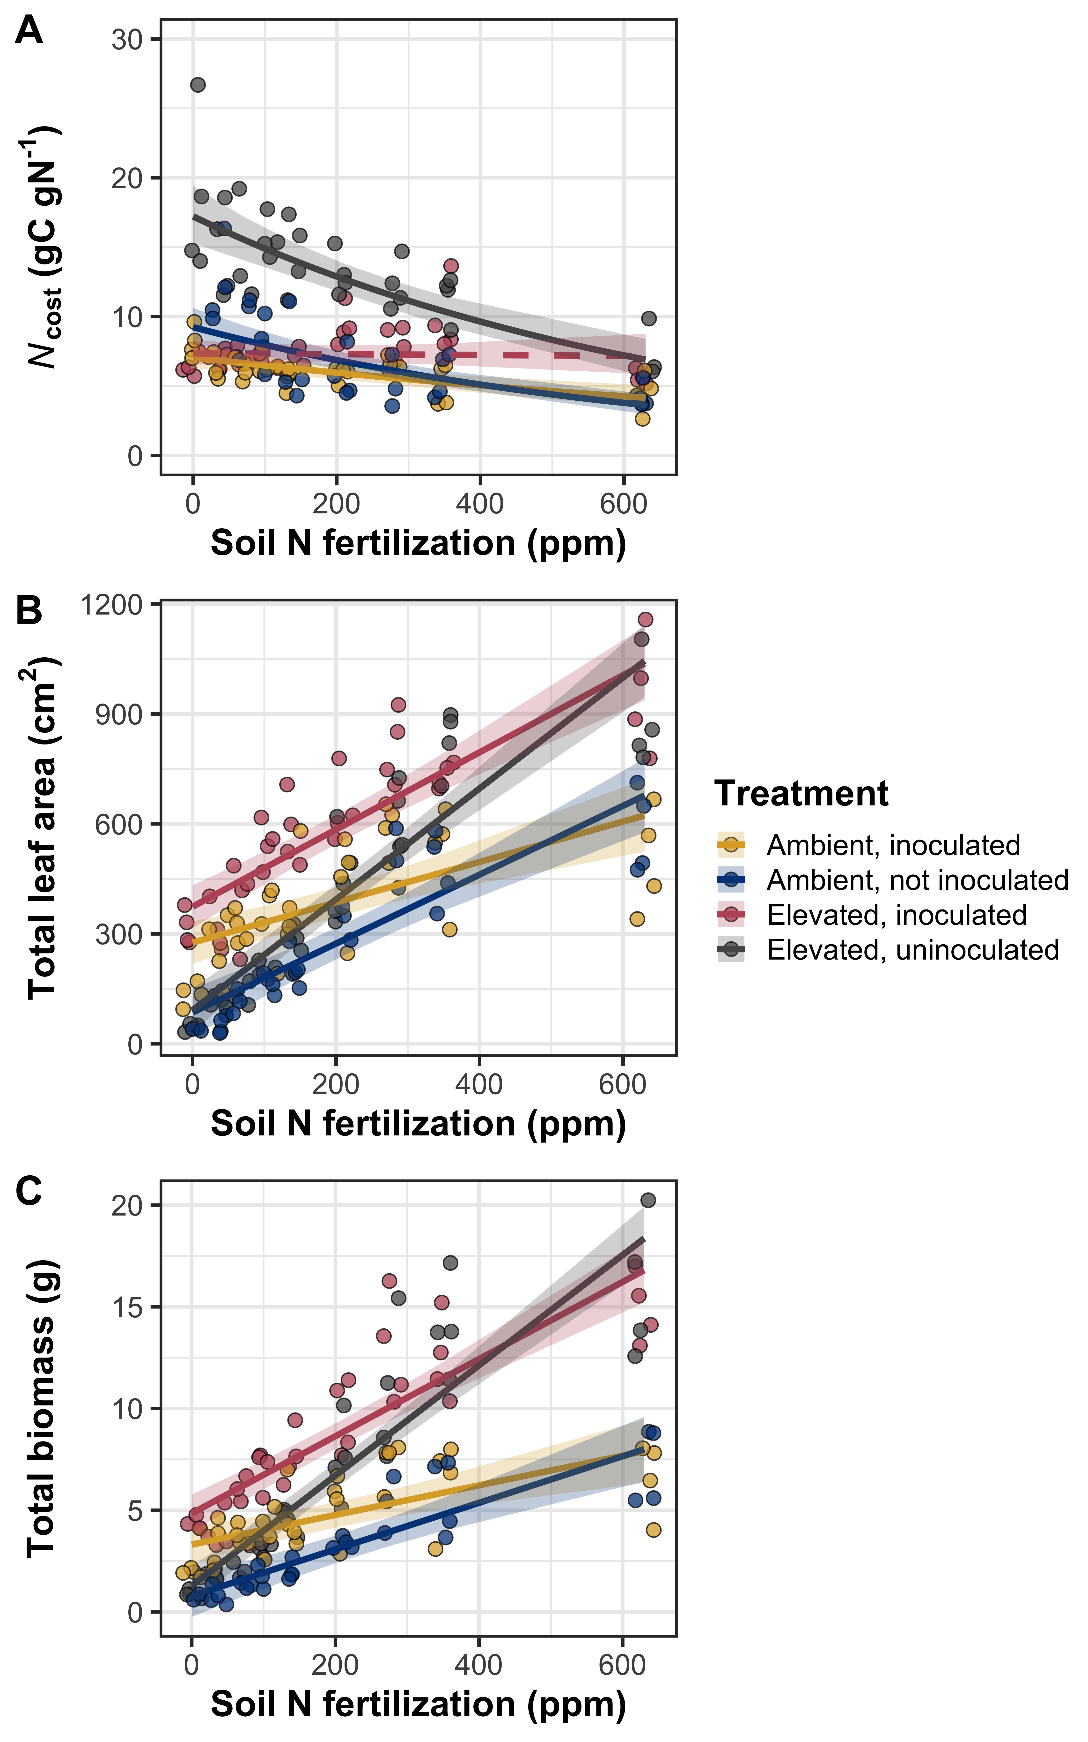

**Figure 1** Effects of nitrogen fertilization, inoculation treatment, and CO2 treatment on structural carbon costs to acquire nitrogen (panel A), total leaf area (panel B), and total biomass (panel C). Soil nitrogen fertilization is represented continuously on the x-axis. Yellow points and trendlines indicate inoculated individuals grown under ambient CO2, blue points and trendlines indicate uninoculated individuals grown under ambient CO2, red points and trendlines indicate inoculated individuals grown under elevated CO2, and grey points indicate uninoculated individuals grown under elevated CO2. Solid trendlines indicate slopes that are different from zero (p<0.05), while dashed trendlines indicate slopes that are not different from zero (p>0.05). Error ribbons represent upper and lower 95% confidence intervals, calculated using the ‘emmeans’ R package (Lenth, 2019).

*Leaf N content*

Leaf nitrogen per unit leaf area was driven by two, two-way interactions between inoculation treatment and nitrogen fertilization and between CO2 treatment and nitrogen fertilization (Table 2). The interaction between inoculation treatment and nitrogen fertilization indicated that the general positive effect of increasing fertilization on *N*area was stronger in uninoculated pots (Tukey: p<0.001), while the interaction between CO2 treatment and nitrogen fertilization indicated that the general positive effect of increasing fertilization on *N*area was stronger in the ambient CO2 treatment (Tukey: p=0.003). There was also a marginal interaction between inoculation and CO2 treatment, indicating a stronger positive effect of inoculation on *N*area in the elevated CO2 treatment (44% increase) compared to the ambient CO2 treatment (20% increase) despite the inoculation effect being statistically significant within each CO2 treatments (Tukey: p<0.001 in both cases).

[Nmass]

[Marea]

**Table 2** Effects of soil nitrogen fertilization, inoculation, and CO2 on leaf nitrogen content per unit leaf area, leaf nitrogen content, and leaf mass per area*

|  |  |  |  |  |  |  |  |  |  |  |
| --- | --- | --- | --- | --- | --- | --- | --- | --- | --- | --- |
|  |  | ***N*area** | | | ***N*mass** | | | ***M*areaa** | | |
|  | df | Coefficient | *χ*2 | p-value | Coefficient | *χ*2 | p-value | Coefficient | *χ*2 | p-value |
| (Intercept) | - | 1.72E+00 | - | - | 3.81E-02 | - | - | 3.82E+00 | - | - |
| CO2 | 1 | -3.04E-01 | 162.696 | **<0.001** | -1.40E-02 | 300.199 | **<0.001** | 2.67E-01 | 141.475 | **<0.001** |
| Inoculation (I) | 1 | -6.49E-01 | 111.725 | **<0.001** | -7.97E-03 | 21.731 | **<0.001** | -1.99E-01 | 26.096 | **<0.001** |
| N fertilization (N) | 1 | 1.70E-03 | 365.400 | **<0.001** | 3.77E-05 | 121.239 | **<0.001** | -3.10E-05 | 28.708 | **<0.001** |
| CO2*I | 1 | -1.54E-01 | 3.030 | *0.082* | -2.74E-03 | 1.635 | 0.201 | 5.15E-02 | 0.148 | 0.700 |
| CO2*N | 1 | -6.91E-04 | 9.397 | **0.002** | -3.12E-05 | 28.554 | **<0.001** | 4.12E-04 | 7.560 | **0.006** |
| I*N | 1 | 1.42E-03 | 45.848 | **<0.001** | 2.10E-05 | 12.673 | **<0.001** | 3.80E-04 | 6.056 | **0.014** |
| CO2*I*N | 1 | 6.36E-05 | 0.022 | 0.883 | -2.19E-07 | <0.001 | 0.985 | -1.69E-04 | 0.495 | 0.482 |

*Significance determined using Type II Wald χ2 tests (α=0.05). *P*-values less than 0.05 are in bold and p-values between 0.05 and 0.10 are italicized. Superscripts after trait labels indicate whether models were fit with natural log (a) or square root (b) transformed response variables. Key: df=degrees of freedom, *N*area=leaf nitrogen content per unit leaf area, *N*mass=leaf nitrogen content, *M*area=leaf mass per unit leaf area.

**Figure 2**

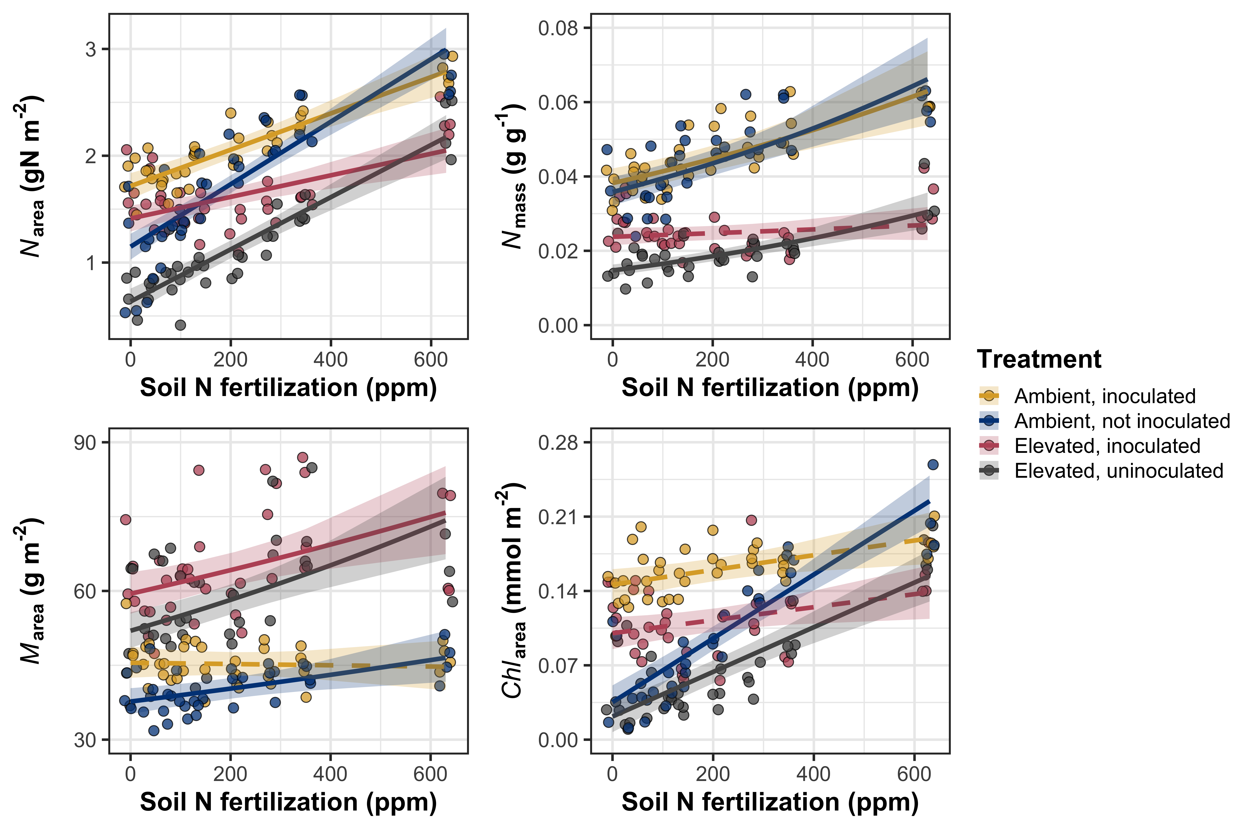

**Figure 2** Effects of nitrogen fertilization, inoculation treatment, and CO2 treatment on leaf nitrogen per unit leaf area (panel A), leaf nitrogen content (panel B), leaf mass per unit leaf area (panel C), and chlorophyll content per unit leaf area (panel D). Soil nitrogen fertilization is represented continuously on the x-axis. Yellow points and trendlines indicate inoculated individuals grown under ambient CO2, blue points and trendlines indicate uninoculated individuals grown under ambient CO2, red points and trendlines indicate inoculated individuals grown under elevated CO2, and grey points indicate uninoculated individuals grown under elevated CO2. Solid trendlines indicate slopes that are different from zero (p<0.05), while dashed trendlines indicate slopes that are not different from zero (p>0.05). Error ribbons represent upper and lower 95% confidence intervals, calculated using the ‘emmeans’ R package (Lenth, 2019).

*Gas exchange*

**Table 3** Effects of soil nitrogen fertilization, inoculation, and CO2 on leaf gas exchange*

|  |  |  |  |  |  |  |  |  |  |  |
| --- | --- | --- | --- | --- | --- | --- | --- | --- | --- | --- |
|  |  | ***V*cmax25** | | | ***J*cmax25** | | | ***J*cmax25: *V*cmax25** | | |
|  | df | Coefficient | *χ*2 | p-value | Coefficient | *χ*2 | p-value | Coefficient | *χ*2 | p-value |
| (Intercept) | - | 1.02E+02 | - | - | 1.79E+02 | - | - | 1.74E+00 | - | - |
| CO2 | 1 | -1.17E+01 | 16.477 | **<0.001** | -8.29E+00 | 5.742 | **0.017** | 1.44E-01 | 67.236 | **<0.001** |
| Inoculation (I) | 1 | -6.02E+01 | 131.881 | **<0.001** | -9.88E+01 | 115.281 | **<0.001** | 1.79E-01 | 33.861 | **<0.001** |
| N fertilization (N) | 1 | -4.10E-03 | 49.486 | **<0.001** | -2.18E-02 | 35.41 | **<0.001** | -1.37E-04 | 31.352 | **<0.001** |
| CO2*I | 1 | 6.29E+00 | <0.001 | 0.990 | 1.77E+00 | 0.440 | 0.507 | -8.15E-02 | 3.231 | *0.072* |
| CO2*N | 1 | -8.70E-03 | 2.591 | 0.107 | -8.76E-03 | 1.148 | 0.284 | 8.33E-05 | 3.871 | **0.049** |
| I*N | 1 | 1.39E-01 | 68.330 | **<0.001** | 2.36E-01 | 64.870 | **<0.001** | -3.25E-04 | 10.531 | **0.001** |
| CO2*I*N | 1 | -3.09E-02 | 1.070 | 0.301 | -4.04E-02 | 0.570 | 0.450 | 1.42E-04 | 0.836 | 0.361 |
|  |  |  |  |  |  |  |  |  |  |  |
|  |  | ***g*swb** | | | ***C*i:*C*a** | | | **Stomatal limitation** | | |
|  | df | Coefficient | *χ*2 | p-value | Coefficient | *χ*2 | p-value | Coefficient | *χ*2 | p-value |
| (Intercept) | - | 5.65E-01 | - | - | 6.96E-01 | - | - | 2.90E-01 | - | - |
| CO2 | 1 | 9.24E-03 | 6.305 | **0.012** | 2.26E-02 | 0.846 | 0.358 | -3.96E-02 | 1.059 | 0.303 |
| Inoculation (I) | 1 | -1.76E-01 | 41.517 | **<0.001** | 3.22E-02 | 1.555 | 0.212 | -6.44E-02 | 4.055 | **0.044** |
| N fertilization (N) | 1 | -7.09E-05 | 1.726 | 0.189 | -9.92E-05 | 26.163 | **<0.001** | 9.51E-05 | 34.274 | **<0.001** |
| CO2*I | 1 | -4.60E-02 | 1.173 | 0.279 | -2.77E-02 | 0.758 | 0.384 | 5.93E-02 | 3.143 | *0.076* |
| CO2*N | 1 | -1.63E-04 | 2.461 | 0.117 | -1.96E-05 | 0.040 | 0.841 | 4.27E-05 | 0.151 | 0.697 |
| I*N | 1 | 4.14E-04 | 23.704 | **<0.001** | -6.24E-05 | 0.443 | 0.506 | 1.36E-04 | 1.936 | 0.164 |
| CO2*I*N | 1 | 4.53E-05 | 0.063 | 0.801 | 5.91E-05 | 0.361 | 0.548 | -1.26E-04 | 1.440 | 0.230 |

*Significance determined using Type II Wald χ2 tests (α=0.05). *P*-values less than 0.05 are in bold and p-values between 0.05 and 0.10 are italicized. Superscripts after trait labels indicate whether models were fit with natural log (a) or square root (b) transformed response variables. Key: df=degrees of freedom, *V*cmax25=maximum rate of Rubisco carboxylation at 25°C; *J*max25=maximum rate of RuBP regeneration at 25°C, *J*max25:*V*cmax25=ratio of *J*max25 to *V*cmax25; *g*sw= stomatal conductance; *C*i:*C*a=ratio of intercellular CO2 to extracellular CO2

**Figure 3**

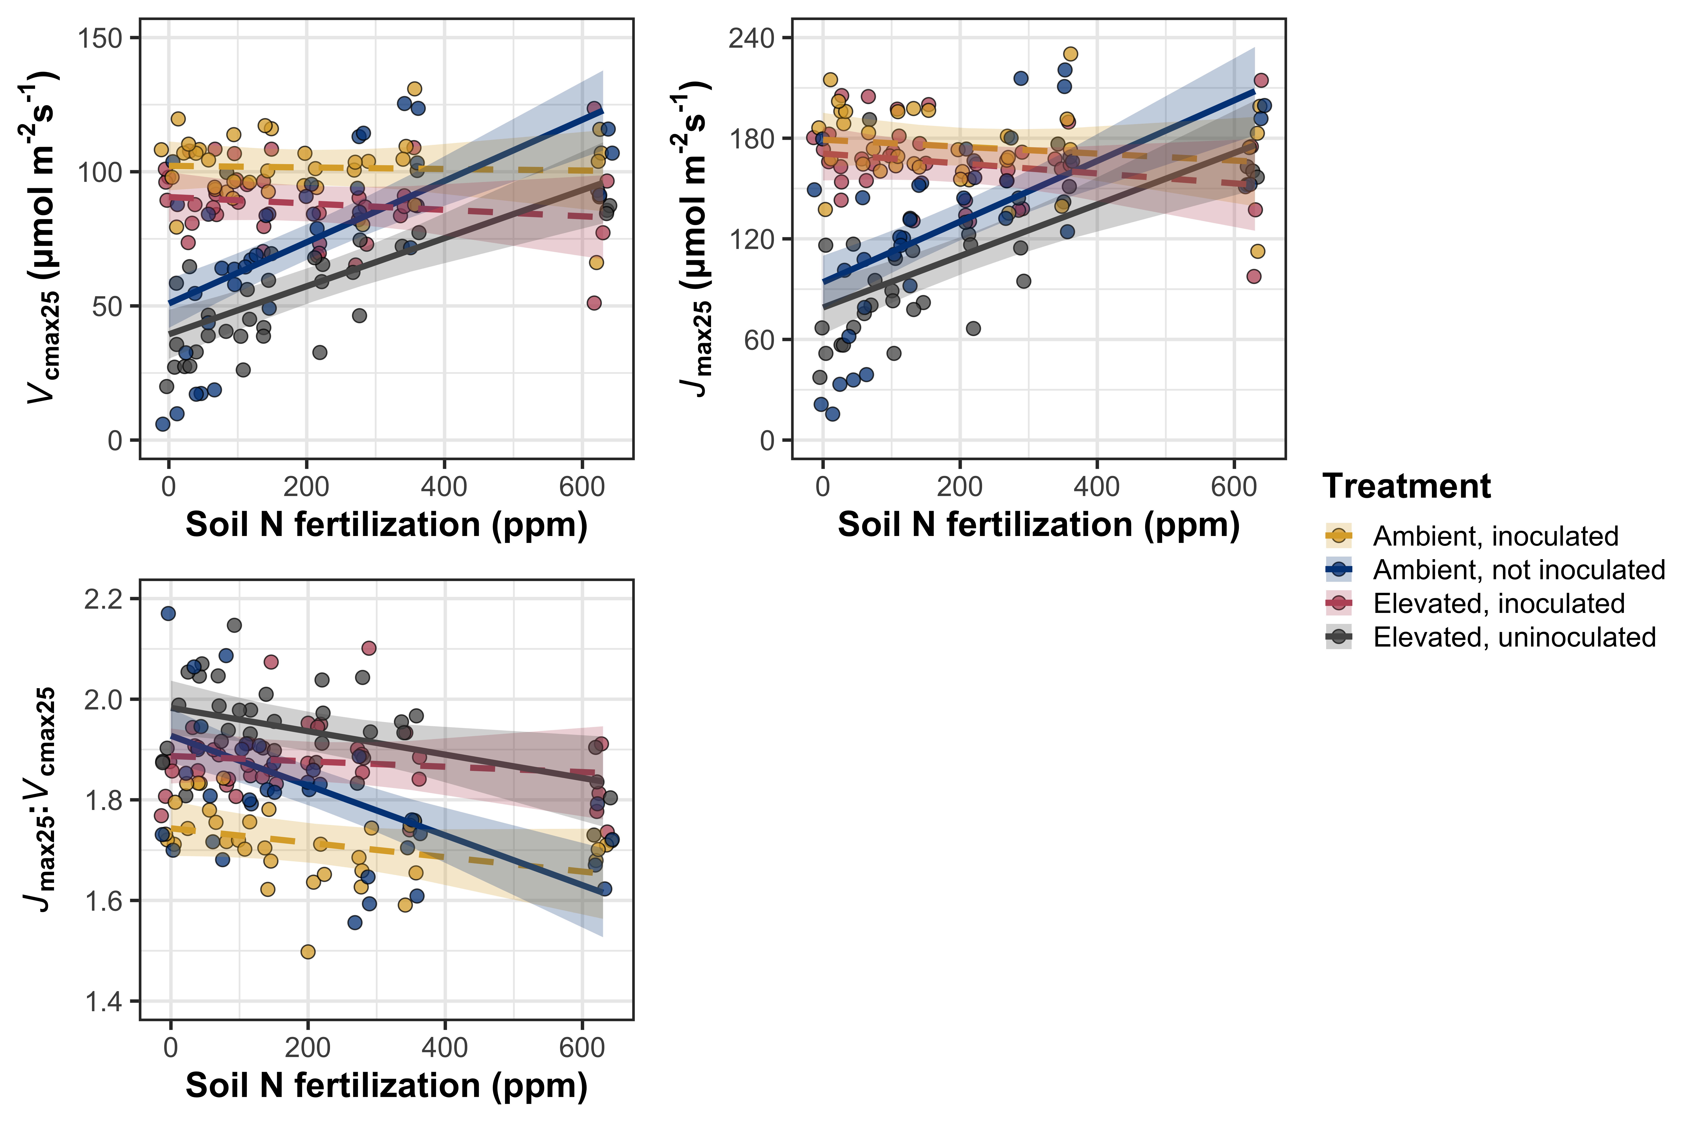

**Figure 3** Effects of soil nitrogen fertilization, inoculation treatment, and CO2 treatment on the maximum rate of Rubisco carboxylation (panel A), the maximum rate of RuBP regeneration (panel B), and the ratio of the maximum rate of RuBP regeneration to the maximum rate of Rubisco carboxylation (panel C).Soil nitrogen fertilization is represented continuously on the x-axis. Yellow points and trendlines indicate inoculated individuals grown under ambient CO2, blue points and trendlines indicate uninoculated individuals grown under ambient CO2, red points and trendlines indicate inoculated individuals grown under elevated CO2, and grey points indicate uninoculated individuals grown under elevated CO2. Solid trendlines indicate slopes that are different from zero (p<0.05), while dashed trendlines indicate slopes that are not different from zero (p>0.05). Error ribbons represent upper and lower 95% confidence intervals, calculated using the ‘emmeans’ R package (Lenth, 2019).

*Leaf nitrogen allocation*

**Table 4** Effects of soil nitrogen fertilization, inoculation, and CO2 on the fraction of leaf nitrogen allocated to Rubisco, bioenergetics, light harvesting proteins, photosynthesis, and structure*

|  |  |  |  |  |  |  |  |  |  |  |
| --- | --- | --- | --- | --- | --- | --- | --- | --- | --- | --- |
|  |  | ***ρ*rubisco** | | | ***ρ*bioe** | | | ***ρ*light** | | |
|  | df | Coefficient | *χ*2 | p-value | Coefficient | *χ*2 | p-value | Coefficient | *χ*2 | p-value |
| (Intercept) | - | 4.54E-01 | - | - | 8.06E-02 | - | - | 1.69E-01 | - | - |
| CO2 | 1 | 3.88E-02 | 17.242 | **<0.001** | 1.35E-02 | 48.450 | **<0.001** | -1.00E-02 | 0.136 | 0.713 |
| Inoculation (I) | 1 | -1.81E-01 | 27.778 | **<0.001** | -2.76E-02 | 16.584 | **<0.001** | -7.72E-02 | 145.562 | **<0.001** |
| N fertilization (N) | 1 | -2.95E-04 | 14.675 | **<0.001** | -5.68E-05 | 24.335 | **<0.001** | -3.29E-05 | 29.083 | **<0.001** |
| CO2*I | 1 | 9.20E-02 | 4.069 | **0.044** | 1.46E-02 | 2.504 | 0.114 | 2.76E-02 | 1.994 | 0.158 |
| CO2*N | 1 | 1.01E-05 | 1.721 | 0.190 | 3.17E-06 | 1.261 | 0.261 | 3.95E-05 | 0.090 | 0.764 |
| I*N | 1 | 4.29E-04 | 23.289 | **<0.001** | 6.86E-05 | 16.774 | **<0.001** | 1.66E-04 | 49.891 | **<0.001** |
| CO2*I*N | 1 | -2.01E-04 | 2.178 | 0.140 | -3.49E-05 | 1.982 | 0.159 | -9.00E-05 | 6.800 | **0.009** |
|  |  |  |  |  |  |  |  |  |  |  |
|  |  | ***ρ*photo** | | | ***ρ*structure** | | |  |  |  |
|  | df | Coefficient | *χ*2 | p-value | Coefficient | *χ*2 | p-value |  |  |  |
| (Intercept) | - | 5.63E-01 | NA | NA | -3.19E+00 | NA | NA |  |  |  |
| CO2 | 1 | 4.89E-02 | 19.829 | <0.001 | 5.81E-01 | 252.539 | <0.001 |  |  |  |
| Inoculation (I) | 1 | -2.28E-01 | 30.058 | <0.001 | -1.09E-02 | 10.043 | 0.002 |  |  |  |
| N fertilization (N) | 1 | -3.63E-04 | 13.626 | <0.001 | -7.96E-04 | 42.191 | <0.001 |  |  |  |
| CO2*I | 1 | 1.18E-01 | 4.237 | 0.04 | 4.32E-01 | 11.835 | 0.001 |  |  |  |
| CO2*N | 1 | 2.66E-05 | 1.695 | 0.193 | 7.48E-04 | 3.072 | 0.08 |  |  |  |
| I*N | 1 | 5.41E-04 | 24.518 | <0.001 | -4.95E-05 | 5.455 | 0.02 |  |  |  |
| CO2*I*N | 1 | -2.68E-04 | 2.685 | 0.101 | -8.27E-04 | 4.176 | 0.041 |  |  |  |

*Significance determined using Type II Wald χ2 tests (α=0.05). *P*-values less than 0.05 are in bold and p-values between 0.05 and 0.10 are italicized. Superscripts after trait labels indicate whether models were fit with natural log (a) or square root (b) transformed response variables. Key: df=degrees of freedom, *ρ*rubisco= proportion of leaf N allocated to photosynthesis; *ρ*bioe= proportion of leaf N allocated to bioenergetics, *ρ*light=proportion of leaf N allocated to light harvesting proteins; *ρ*photo=proportion of leaf N allocated to photosynthesis; *ρ*structure=proportion of leaf N allocated to cell wall structural tissue

**Figure 4**

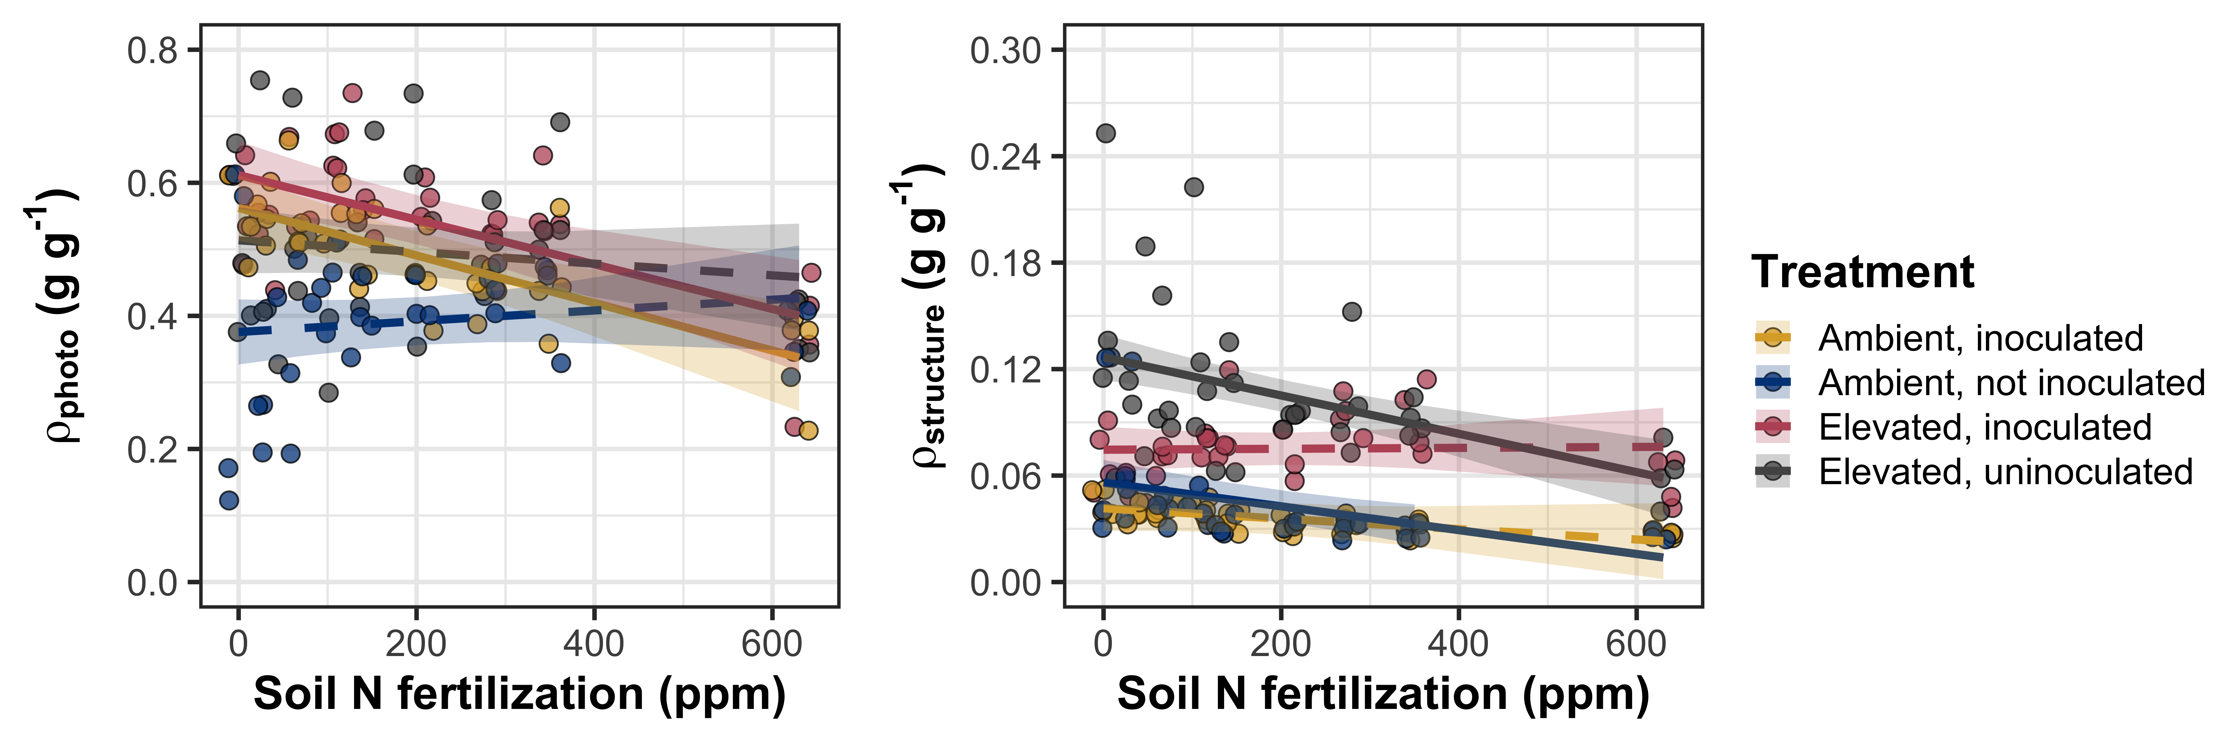

**Figure 4**

Soil nitrogen fertilization is represented continuously on the x-axis. Yellow points and trendlines indicate inoculated individuals grown under ambient CO2, blue points and trendlines indicate uninoculated individuals grown under ambient CO2, red points and trendlines indicate inoculated individuals grown under elevated CO2, and grey points indicate uninoculated individuals grown under elevated CO2. Solid trendlines indicate slopes that are different from zero (p<0.05), while dashed trendlines indicate slopes that are not different from zero (p>0.05). Error ribbons represent upper and lower 95% confidence intervals, calculated using the ‘emmeans’ R package (Lenth, 2019)

*Tradeoffs between nitrogen and water use*

**Table 5**

|  |  |  |  |  |  |  |  |  |  |  |
| --- | --- | --- | --- | --- | --- | --- | --- | --- | --- | --- |
|  |  | ***PNUE*** | | | ***iWUE*** | | | ***N*area:*g*sw** | | |
|  | df | Coefficient | *χ*2 | p-value | Coefficient | *χ*2 | p-value | Coefficient | *χ*2 | p-value |
| (Intercept) | - | 1.19E+01 | - | - | 6.47E+01 | - | - | 1.66E+00 | - | - |
| CO2 | 1 | 1.65E+00 | 18.586 | **<0.001** | -4.71E+00 | 0.078 | 0.780 | -1.99E-01 | 6.639 | **0.010** |
| Inoculation (I) | 1 | -4.21E+00 | 22.792 | **<0.001** | -3.28E+00 | 0.008 | 0.928 | 4.85E-01 | 6.729 | 0.009 |
| N fertilization (N) | 1 | -8.32E-03 | 23.161 | **<0.001** | 2.44E-02 | 18.444 | **<0.001** | 1.25E-03 | 21.138 | **<0.001** |
| CO2*I | 1 | 1.29E+00 | 0.603 | 0.437 | 6.97E+00 | 0.754 | 0.385 | -1.70E-01 | 0.348 | 0.555 |
| CO2*N | 1 | -1.13E-03 | 1.789 | 0.181 | 9.31E-03 | 0.035 | 0.851 | 2.50E-04 | 1.321 | 0.250 |
| I*N | 1 | 9.90E-03 | 16.025 | **<0.001** | 4.41E-03 | 0.039 | 0.843 | -1.21E-03 | 6.687 | **0.010** |
| CO2*I*N | 1 | -3.32E-03 | 0.656 | 0.418 | -1.39E-02 | 0.287 | 0.592 | 4.04E-04 | 0.271 | 0.603 |
|  |  |  |  |  |  |  |  |  |  |  |
|  |  | ***V*cmax25:*g*sw** | | |  |  |  |  |  |  |
|  |  | Coefficient | *χ*2 | p-value |  |  |  |  |  |  |
| (Intercept) | - | 5.72E+00 | - | - |  |  |  |  |  |  |
| CO2 | 1 | -1.09E-01 | 0.015 | 0.903 |  |  |  |  |  |  |
| Inoculation (I) | 1 | -1.04E-01 | 0.011 | 0.916 |  |  |  |  |  |  |
| N fertilization (N) | 1 | 5.01E-04 | 19.366 | **<0.001** |  |  |  |  |  |  |
| CO2*I | 1 | 2.35E-01 | 1.876 | 0.171 |  |  |  |  |  |  |
| CO2*N | 1 | 2.59E-04 | 0.006 | 0.937 |  |  |  |  |  |  |
| I*N | 1 | 1.83E-04 | 0.043 | 0.835 |  |  |  |  |  |  |
| CO2*I*N | 1 | -4.78E-04 | 0.761 | 0.383 |  |  |  |  |  |  |

*Significance determined using Type II Wald χ2 tests (α=0.05). *P*-values less than 0.05 are in bold and p-values between 0.05 and 0.10 are italicized. Superscripts after trait labels indicate whether models were fit with natural log (a) or square root (b) transformed response variables. Key: df=degrees of freedom, PNUE=photosynthetic nitrogen-use efficiency, iWUE=intrinsic water-use efficiency, *N*area:*g*sw=ratio of leaf nitrogen per unit leaf area to stomatal conductance, *V*cmax25:*g*sw=maximum Rubisco carboxylation rate to stomatal conductance

**Figure 5**

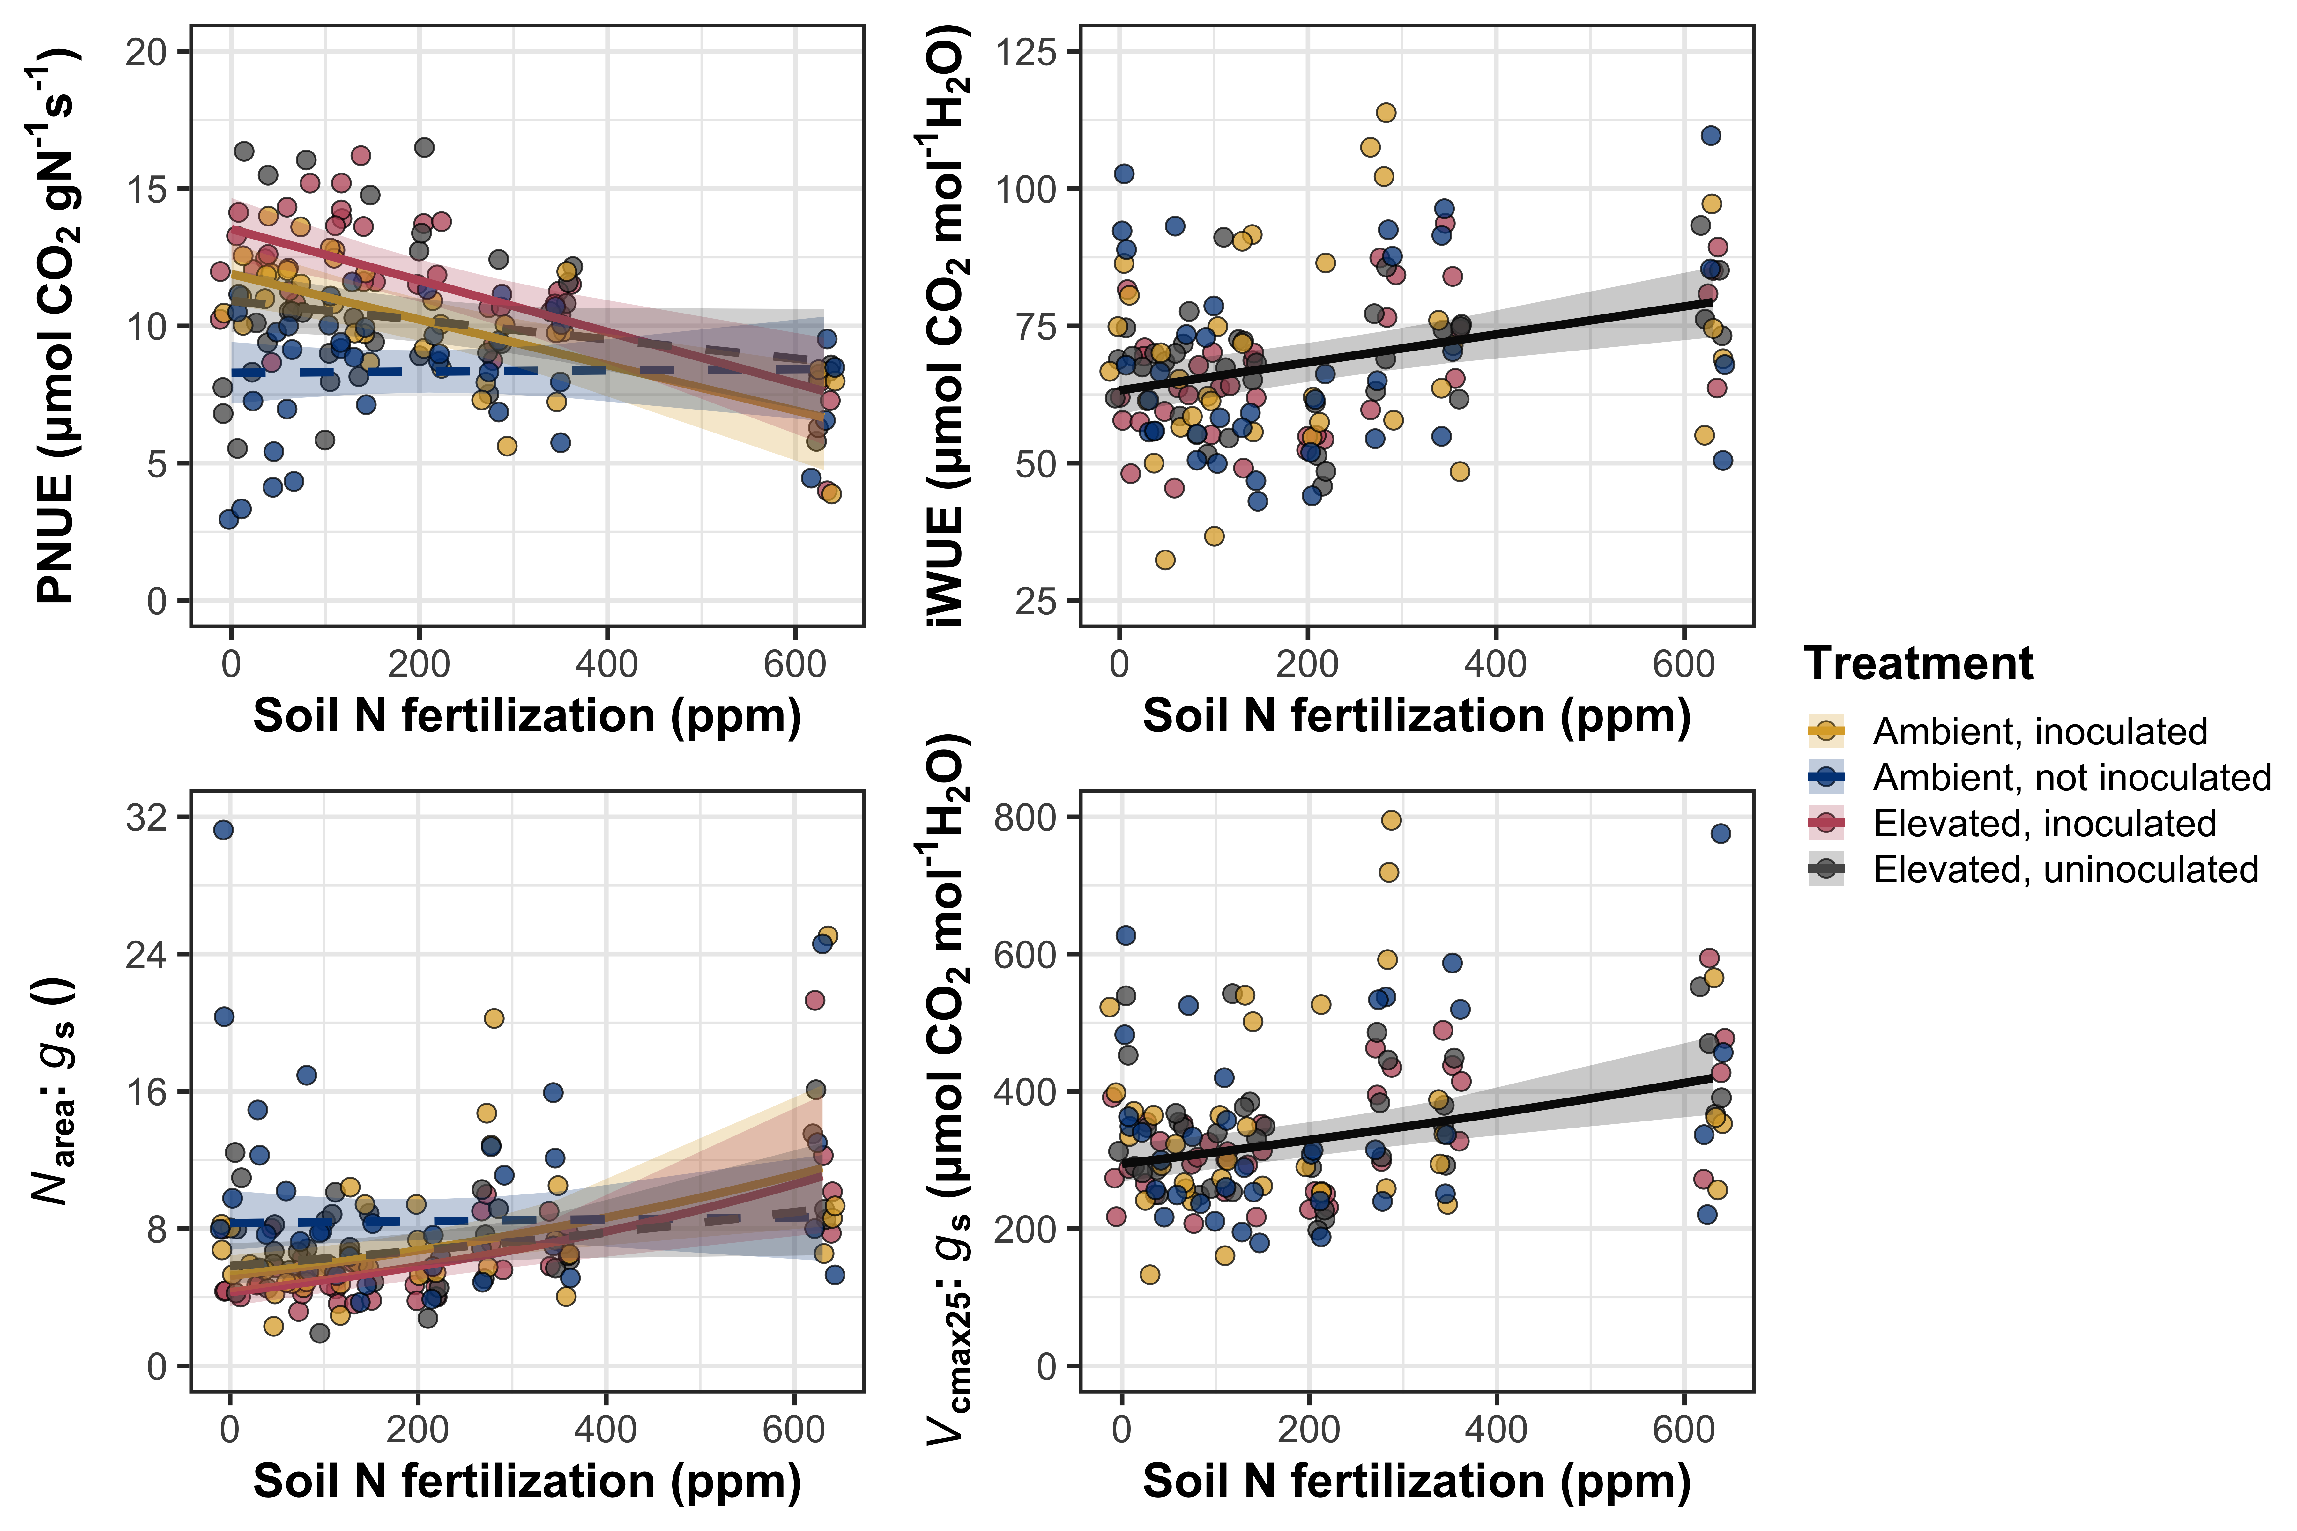

**Figure 5**

Soil nitrogen fertilization is represented continuously on the x-axis. Yellow points and trendlines indicate inoculated individuals grown under ambient CO2, blue points and trendlines indicate uninoculated individuals grown under ambient CO2, red points and trendlines indicate inoculated individuals grown under elevated CO2, and grey points indicate uninoculated individuals grown under elevated CO2. Solid trendlines indicate slopes that are different from zero (p<0.05), while dashed trendlines indicate slopes that are not different from zero (p>0.05). Error ribbons represent upper and lower 95% confidence intervals, calculated using the ‘emmeans’ R package (Lenth, 2019)

*Nitrogen fixation*

**Table 6**

**Figure 6**

**Figure 6**

Soil nitrogen fertilization is represented continuously on the x-axis. Yellow points and trendlines indicate inoculated individuals grown under ambient CO2, blue points and trendlines indicate uninoculated individuals grown under ambient CO2, red points and trendlines indicate inoculated individuals grown under elevated CO2, and grey points indicate uninoculated individuals grown under elevated CO2. Solid trendlines indicate slopes that are different from zero (p<0.05), while dashed trendlines indicate slopes that are not different from zero (p>0.05). Error ribbons represent upper and lower 95% confidence intervals, calculated using the ‘emmeans’ R package (Lenth, 2019)

**Discussion**

**References**

Ainsworth, E. A., Davey, P. A., Bernacchi, C. J., Dermody, O. C., Heaton, E. A., Moore, D. J., Morgan, P. B., Naidu, S. L., Ra, H. S. Y., Zhu, X. G., Curtis, P. S., & Long, S. P. (2002). A meta-analysis of elevated [CO2] effects on soybean (Glycine max) physiology, growth and yield. *Global Change Biology*, *8*(8), 695–709. https://doi.org/10.1046/j.1365-2486.2002.00498.x

Ainsworth, E. A., & Rogers, A. (2007). The response of photosynthesis and stomatal conductance to rising [CO2]: mechanisms and environmental interactions. *Plant, Cell & Environment*, *30*(3), 258–270. https://doi.org/10.1111/j.1365-3040.2007.01641.x

Andrews, M., James, E. K., Sprent, J. I., Boddey, R. M., Gross, E., & dos Reis, F. B. (2011). Nitrogen fixation in legumes and actinorhizal plants in natural ecosystems: Values obtained using 15N natural abundance. *Plant Ecology and Diversity*, *4*(2–3), 117–130. https://doi.org/10.1080/17550874.2011.644343

Bates, D., Mächler, M., Bolker, B., & Walker, S. (2015). Fitting linear mixed-effects models using lme4. *Journal of Statistical Software*, *67*(1), 1–48. https://doi.org/10.18637/jss.v067.i01

Bengtson, P., Barker, J., & Grayston, S. J. (2012). Evidence of a strong coupling between root exudation, C and N availability, and stimulated SOM decomposition caused by rhizosphere priming effects. *Ecology and Evolution*, *2*(8), 1843–1852. https://doi.org/10.1002/ece3.311

Bernacchi, C. J., Singsaas, E. L., Pimentel, C., Portis, A. R., & Long, S. P. (2001). Improved temperature response functions for models of Rubisco-limited photosynthesis. *Plant, Cell and Environment*, *24*(2), 253–259. https://doi.org/10.1046/j.1365-3040.2001.00668.x

Cernusak, L. A., Ubierna, N., Winter, K., Holtum, J. A. M., Marshall, J. D., & Farquhar, G. D. (2013). Environmental and physiological determinants of carbon isotope discrimination in terrestrial plants. *New Phytologist*, *200*(4), 950–965. https://doi.org/10.1111/nph.12423

Curtis, P. S. (1996). A meta-analysis of leaf gas exchange and nitrogen in trees grown under elevated carbon dioxide. *Plant, Cell and Environment*, *19*(2), 127–137. https://doi.org/10.1111/j.1365-3040.1996.tb00234.x

Dovrat, G., Bakhshian, H., Masci, T., & Sheffer, E. (2020). The nitrogen economic spectrum of legume stoichiometry and fixation strategy. *New Phytologist*, *227*(2), 365–375. https://doi.org/10.1111/nph.16543

Dovrat, G., Masci, T., Bakhshian, H., Mayzlish Gati, E., Golan, S., & Sheffer, E. (2018). Drought-adapted plants dramatically downregulate dinitrogen fixation: Evidences from Mediterranean legume shrubs. *Journal of Ecology*, *106*(4), 1534–1544. https://doi.org/10.1111/1365-2745.12940

Duursma, R. (2015). Plantecophys - An R package for analyzing and modelling leaf gas exchange data. *PLos ONE*, *10*(11), e0143346. https://doi.org/10.1371/journal.pone.0143346>

Evans, J. R. (1989). Photosynthesis and nitrogen relationships in leaves of C3 plants. *Oecologia*, *78*(1), 9–19. https://doi.org/10.1007/BF00377192

Farquhar, G. D., Ehleringer, J. R., & Hubick, K. T. (1989). Carbon isotope discrimination and photosynthesis. *Annual Review of Plant Physiology and Plant Molecular Biology*, *40*(1), 503–537. https://doi.org/10.1146/annurev.pp.40.060189.002443

Farquhar, G. D., & Sharkey, T. D. (1982). Stomatal conductance and photosynthesis. *Annual Review of Plant Physiology*, *33*(1), 317–345. https://doi.org/10.1146/annurev.pp.33.060182.001533

Farquhar, G. D., von Caemmerer, S., & Berry, J. A. (1980). A biochemical model of photosynthetic CO*2* assimilation in leaves of C3 species. *Planta*, *149*(1), 78–90. https://doi.org/10.1007/BF00386231

Fay, P. A., Prober, S. M., Harpole, W. S., Knops, J. M. H., Bakker, J. D., Borer, E. T., Lind, E. M., MacDougall, A. S., Seabloom, E. W., Wragg, P. D., Adler, P. B., Blumenthal, D. M., Buckley, Y. M., Chu, C., Cleland, E. E., Collins, S. L., Davies, K. F., Du, G., Feng, X., … Yang, L. H. (2015). Grassland productivity limited by multiple nutrients. *Nature Plants*, *1*(7), 15080. https://doi.org/10.1038/nplants.2015.80

Fox, J., & Weisberg, S. (2019). *An R companion to applied regression* (Third edit). Sage. https://socialsciences.mcmaster.ca/jfox/Books/Companion/

Glover, J. (1973). The dark respiration of sugar-cane and the loss of photosynthate during the growth of a crop. *Annals of Botany*, *37*(4), 845–852. https://doi.org/10.1093/oxfordjournals.aob.a084753

Hoagland, D. R., & Arnon, D. I. (1950). The water-culture method for growing plants without soil. *California Agricultural Experiment Station: 347*, *347*(2), 1–32.

Hungate, B. A., Dukes, J. S., Shaw, M. R., Luo, Y., & Field, C. B. (2003). Nitrogen and climate change. *Science*, *302*(5650), 1512–1513. https://doi.org/10.1126/science.1091390

IPCC. (2013). *Climate Change 2013: The Physical Science Basis. Contribution of Working Group I to the Fifth Assessment Report of the Intergovernmental Panel on Climate Change*.

Katabuchi, M. (2015). LeafArea: An R package for rapid digital analysis of leaf area. *Ecological Research*, *30*(6), 1073–1077.

Keeling, C. D., Mook, W. G., & Tans, P. P. (1979). Recent trends in the 13C/12C ratio of atmospheric carbon dioxide. *Nature*, *277*(5692), 121–123. https://doi.org/10.1038/277121a0

Kenward, M. G., & Roger, J. H. (1997). Small sample inference for fixed effects from restricted maximum likelihood. *Biometrics*, *53*(3), 983. https://doi.org/10.2307/2533558

LeBauer, D. S., & Treseder, K. (2008). Nitrogen limitation of net primary productivity. *Ecology*, *89*(2), 371–379. https://doi.org/10.1890/06-2057.1

Lenth, R. (2019). *emmeans: estimated marginal means, aka least-squares means*.

Liang, J., Qi, X., Souza, L., & Luo, Y. (2016). Processes regulating progressive nitrogen limitation under elevated carbon dioxide: a meta-analysis. *Biogeosciences*, *13*(9), 2689–2699. https://doi.org/10.5194/bg-13-2689-2016

Luo, Y., Currie, W. S., Dukes, J. S., Finzi, A. C., Hartwig, U. A., Hungate, B. A., McMurtrie, R. E., Oren, R., Parton, W. J., Pataki, D. E., Shaw, R. M., Zak, D. R., & Field, C. B. (2004). Progressive nitrogen limitation of ecosystem responses to rising atmospheric carbon dioxide. *BioScience*, *54*(8), 731–739. https://doi.org/10.1641/0006-3568(2004)054[0731:PNLOER]2.0.CO;2

Makino, A. (2003). Rubisco and nitrogen relationships in rice: leaf photosynthesis and plant growth. *Soil Science and Plant Nutrition*, *49*(3), 319–327.

Medlyn, B. E., Dreyer, E., Ellsworth, D. S., Forstreuter, M., Harley, P. C., Kirschbaum, M. U. F., Le Roux, X., Montpied, P., Strassemeyer, J., Walcroft, A., Wang, K., & Loustau, D. (2002). Temperature response of parameters of a biochemically based model of photosynthesis. II. A review of experimental data. *Plant, Cell & Environment*, *25*(9), 1167–1179. https://doi.org/10.1046/j.1365-3040.2002.00891.x

Morgan, J. A., Pataki, D. E., Körner, C., Clark, H., Del Grosso, S. J., Grünzweig, J. M., Knapp, A. K., Mosier, A. R., Newton, P. C. D., Niklaus, P. A., Nippert, J. B., Nowak, R. S., Parton, W. J., Polley, H. W., & Shaw, M. R. (2004). Water relations in grassland and desert ecosystems exposed to elevated atmospheric CO2. *Oecologia*, *140*(1), 11–25. https://doi.org/10.1007/s00442-004-1550-2

Perkowski, E. A., Waring, E. F., & Smith, N. G. (2021). Root mass carbon costs to acquire nitrogen are determined by nitrogen and light availability in two species with different nitrogen acquisition strategies. *Journal of Experimental Botany*, *72*(15), 5766–5776. https://doi.org/10.1093/jxb/erab253

Poorter, H., Knopf, O., Wright, I. J., Temme, A. A., Hogewoning, S. W., Graf, A., Cernusak, L. A., & Pons, T. L. (2022). A meta-analysis of responses of C3 plants to atmospheric CO2: dose–response curves for 85 traits ranging from the molecular to the whole-plant level. *New Phytologist*, *233*(4), 1560–1596. https://doi.org/10.1111/nph.17802

Prentice, I. C., Dong, N., Gleason, S. M., Maire, V., & Wright, I. J. (2014). Balancing the costs of carbon gain and water transport: testing a new theoretical framework for plant functional ecology. *Ecology Letters*, *17*(1), 82–91. https://doi.org/10.1111/ele.12211

R Core Team. (2021). *R: A language and environment for statistical computing* (4.1.1). R Foundation for Statistical Computing. https://www.r-project.org/

Rastetter, E. B., Vitousek, P. M., Field, C. B., Shaver, G. R., Herbert, D., & Ågren, G. I. (2001). Resource optimization and symbiotic nitrogen fixation. *Ecosystems*, *4*(4), 369–388. https://doi.org/10.1007/s10021-001-0018-z

Saathoff, A. J., & Welles, J. (2021). Gas exchange measurements in the unsteady state. *Plant Cell and Environment*, *44*(11), 3509–3523. https://doi.org/10.1111/pce.14178

Schneider, C. A., Rasband, W. S., & Eliceiri, K. W. (2012). NIH Image to ImageJ: 25 years of image analysis. *Nature Methods*, *9*(7), 671–675. https://doi.org/10.1038/nmeth.2089

Smith, N. G., & Dukes, J. S. (2013). Plant respiration and photosynthesis in global-scale models: Incorporating acclimation to temperature and CO2. *Global Change Biology*, *19*(1), 45–63. https://doi.org/10.1111/j.1365-2486.2012.02797.x

Smith, N. G., & Keenan, T. F. (2020). Mechanisms underlying leaf photosynthetic acclimation to warming and elevated CO2 as inferred from least‐cost optimality theory. *Global Change Biology*, *26*(9), 5202–5216. https://doi.org/10.1111/gcb.15212

Smith, S. E., & Read, D. J. (2008). *Mycorrhizal Symbiosis*.

Terrer, C., Vicca, S., Hungate, B. A., Phillips, R. P., & Prentice, I. C. (2016). Mycorrhizal association as a primary control of the CO2 fertilization effect. *Science*, *353*(6294), 72–74. https://doi.org/10.1126/science.aaf4610

Terrer, C., Vicca, S., Stocker, B. D., Hungate, B. A., Phillips, R. P., Reich, P. B., Finzi, A. C., & Prentice, I. C. (2018). Ecosystem responses to elevated <scp>CO</scp> 2 governed by plant–soil interactions and the cost of nitrogen acquisition. *New Phytologist*, *217*(2), 507–522. https://doi.org/10.1111/nph.14872

Wright, I. J., Reich, P. B., & Westoby, M. (2003). Least-cost input mixtures of water and nitrogen for photosynthesis. *The American Naturalist*, *161*(1), 98–111. https://doi.org/0003-0147/2003/16101-010387